Inkscape Tutorials

Inkscape Lesson 1 - Interface and Basic Drawing
https://www.youtube.com/watch?v=8f011wdiW7g&list=PLqazFFzUAPc5lOQwDoZ4Dw2YSXtO7lWNv&index=2
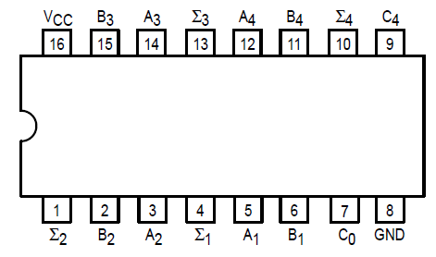

Σ

